**DWIT COLLEGE**

**DEERWALK INSTITUTE OF TECHNOLOGY**



**Water Level Tracking Dashboard**

**Project – I**

**Progress Report**

**Submitted To:**

Department of Computer Science

DWIT College

**Submitted By:**

Bipashree Aryal

16th May 2023

1. **INTRODUCTION**

The Water Level Tracking Dashboard combines hardware and software components to monitor the water level in a household/commercial water tank and analyze water consumption in the building/home.

1. **PROBLEM STATEMENT**

To provide an adequate water supply, many families and business facilities must monitor and control the water level in tanks. In a city like Kathmandu, where the bulk of the water is boring water, monitoring water levels is essential, especially during the winter season when ground water levels are low.

1. **OBJECTIVE**

* To accurately display water consumption in a residential / commercial scenario.
* To monitor water consumption at specific times of the day and facilitate the user to take action to reduce consumption.
* To turn on the motor automatically if the water level falls below a specific level and to turn it off automatically when the water level rises to a specified level.

1. **METHODOLOGY**
   1. Requirement Identification
      1. Study of Existing Systems

There are currently no budget options for what the Water Level Monitoring Dashboard aims to do. Most water level gauges on the market today are either analog or just display the levels on a small 7-Segment Display with no access to the internet and its services. Ivent Solutions Limited (A New Zealand based company) produces a competing solution, however its “Starter Pack” comes at a price of $434.11 with an additional cost of the pump controller at $216.74 making the equivalent solution cost a total of $650.85. [1]

* + 1. Requirement Collection

The Water Level Tracking Dashboard is built using a simple circuit and requires the following hardware resources:

* + - A Microcontroller / Single Board Computer (Raspberry Pi, Arduino, ESP32 etc.)
    - HC – SR04 Sonar Module
    - Relay Module
  1. Feasibility Study
     1. Technical Feasibility

ESP32 Microcontroller in operation recurringly runs an Arduino Programming Language that constantly calculates the water level. The program utilizes to communicate with the HC-SR04 and the Relay Module.

All the software components used in the project are open-source and the hardware components are readily available in the Nepali market.

* + 1. Operational Feasibility

The Hardware Component is an install-once-use-forever solution. It resides on the lid of the water tank and constantly produces output until supplied with power.

* + 1. Economic Feasibility

All the Software Components are Open-Source making them free for any sector of use (personal/commercial).

The Hardware Components are all available for a collective total of Rs. 1500 in the Nepali market.

* 1. System Design
     1. Flowchart

**Figure 1: Flowchart for Water Level Tracking Dashboard**

* + 1. Circuit Diagram

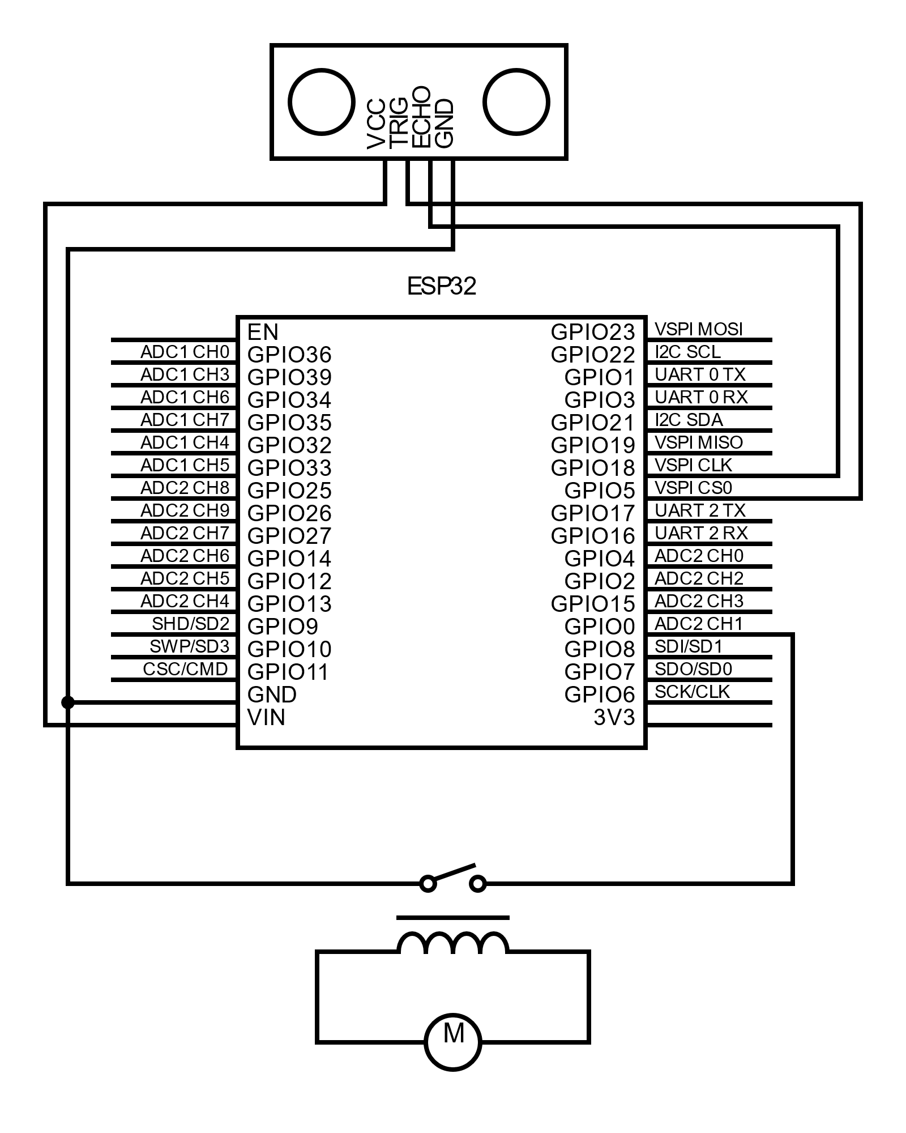

Figure 2: Circuit Diagram for Water Level Tracking Dashboard

* + 1. Block Diagram

Figure 3: Block Diagram for Water Level Tracking Dashboard [2]

1. **GANTT CHART**

Figure 4: Gantt Chart for Water Level Tracking Dashboard

1. **EXPECTED OUTCOME**

Upon completion, the Hardware Component must be able to run the Arduino program continuously without fail and the water level data must be stored in the database continuously.

1. **CONCLUSION**

After completion, this project will be work towards enhancing the convenience in a normal household by eliminating the hassle and stress that comes with manual operation of a water pump to periodically fill the water tank.

# **REFERENCES**

|  |  |
| --- | --- |
| [1] | A. N. R. L. Steven Sachio, "CORE," 14 12 2018. [Online]. Available: https://www.core.ac.uk. [Accessed 10 03 2023]. |
| [2] | M. M. A. K. V. M. Shweta Karad, "IoT Based Water Level Control System," *CORE,* vol. 3, no. 4, p. 251, 4 4 2018. |
| [3] | P. J and S. Chekuri, "Water Level Monitoring System Using IoT," *International Research Journal of Engineering and Technology (IRJET),* vol. 4, no. 12, p. 1817, 2017. |
| [4] | "Smart Water Online," Ivent Solutions Limited, 16 2 2021. [Online]. Available: https://smartwateronline.com/. [Accessed 14 3 2023]. |